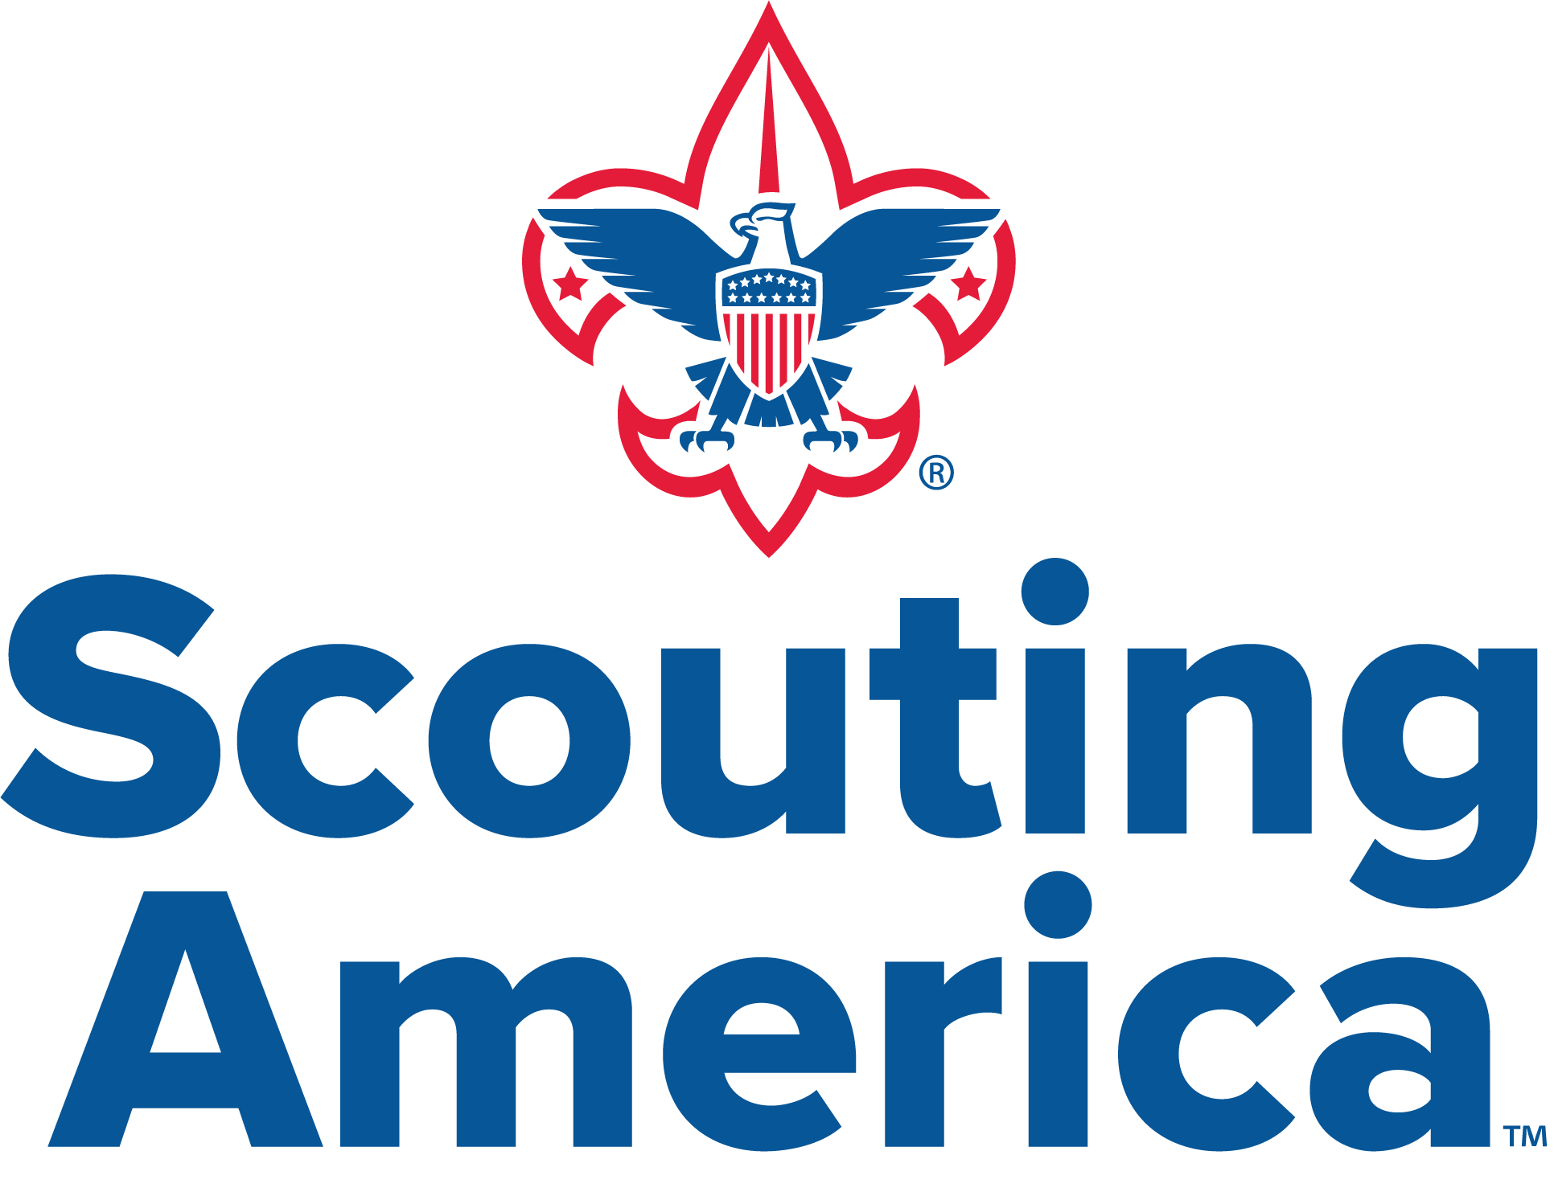

Troop Handbook Scout Troop 212
Chartered by
St. Michaels the Archangel Catholic Church
804 High House Rd
Cary, North Carolina

Scout Troop 212 exists to serve youth by instilling values, preparing them to make ethical choices over their lifetime, and enabling them to achieve their full potential. We accomplish this by working toward three aims – Participating Citizenship; Moral Strength and Character; and Development of Physical, Mental, and Emotional Fitness. Our values are based upon the Scout Oath and Law.

Welcome
Welcome to Troop 212! We are certain that you will have a long, fun, and rewarding experience with us.
Troop 212 operates according to the policies and procedures of Scouting America. Details can be found at www.scouting.org
Our troop's primary goal is youth development, and active parental involvement is essential to achieving this. We need parents to volunteer, as your participation is crucial in enhancing the Scout experience and fostering a supportive community. As a Scout-led troop, Scouts execute the program plans, learning from both successes and failures. Adult volunteers are vital in coaching and inspiring our youth, guiding Scouts while allowing them to take the lead.
If there's anything you'd like to chat about, just reach out to me or any of the other leaders. We're here to help the troop and love hearing your thoughts and ideas. Your feedback helps us make Troop 212 awesome. Whether you've got suggestions, concerns, or just want to share your experiences, we're here to listen and learn.
Yours in Scouting,

Todd E. Qualls
Scoutmaster
Troop 212, Cary NC

Troop 212’s Most Important Information
- Weekly Meetings:
  - The Troop meets on Wednesdays at 7:30PM during the school year. We meet in the Parish Center of St. Michaels the Archangel Catholic church at 804 High House Rd, Cary, NC 27513.
- Troop Outings:
  - We typically have 1 weekend outing per month during the school year.
  - Most Troop Activities will depart from the Food Lion Parking Lot at 1777 W Williams St, Apex, NC 27523. We meet in the parking lot between the Bicycle Chain and Mr. Tire Auto Center.
  - We will always meet with “a full stomach and empty bladder”.
  - We travel in Dress (Class A) uniform.
  - Unlike Cub Scouts, parents may simply drop off their Scouts. The adult leaders have to account for a lot of heads, so we ask that you show up at least 15 minutes before departure and check out with the camp master before you take your son home.
  - Please promptly pick up your Scout upon his return. We can’t go home till all of the Scouts are picked up. We try to give advance warning of arrival times.
  - Summer Camp is a very important part of the Scouting experience. An entire week away from home is a major growth experience, and allows completion of many of their Merit Badges. Consult with Scoutmasters regarding the selection of merit badges.
- Scout Expectations: Scouts are expected to attend at least one weekly meeting per month and 2 troop outings per Scouting season (i.e. Fall & Spring) to be considered active.
- Forms:
  - We need Medical Forms A&B now, we need Part C prior to summer camp. Forms are updated annually, and located at https://www.scouting.org/health-and-safety/ahmr/
  - We will require a Permission form for every activity.
- Expenses:
  - Two Fees are required each year; One to the Council to cover national Scouting fees, insurance, etc…, and one to the Troop to cover local trip and equipment costs.
  - Camping gear – check with adult leaders to see what your son really needs right away. Don’t need to buy all at once, many things can be shared.
  - Fundraising, Troop gear, & Scholarships are available; We do not want cost to be prohibitive.
- Parental Involvement:
  - The Troop expects that every parent/guardian will contribute to the operation of the troop. While understanding that capabilities will vary among parents, we will work with you to define how you can help the troop.
  - If camping isn’t your thing, there are plenty of opportunities for you to contribute like serving as a driver for a camping trip or a committee position.
- Communications:
  - Website is http://bsa212cary.org
  - Scouts/parents should be on the Scout e-mail list server; t212caryscouts@googlegroups.com
    - To join, go to https://groups.google.com/u/1/g/t212caryscouts and “ask to join”/
    - E-mail is the primary means of electronic communications, and provides all vital information. We do not use Slack, Snapchat, or any other group chat apps. Please read and respond to Troop emails in a timely fashion.
  - We use Scoutbook for event RSVPs and tracking advancement; https://scoutbook.scouting.org/
TABLE OF CONTENTS
Welcome 2
Troop 212’s Most Important Information 3
Change Log 6
Mission 7
Safety 7
Scouting Is Different! 7
Some of the key differences between Cub Scouts and Troop 212 8
● Scout led 8
● Different type of adult interaction 8
● Focus on outdoor activities 8
● Focus on building leadership 8
● Self-paced 8
What Does Your Scout Need?The Scout Uniform 9
Camping Gear 11
Membership Application 11
How Much Will It Cost? 12
Annual Dues 12
Camping/Troop Activity Fees 12
Fundraising 12
Approximate Costs 13
Reimbursements 13
Communication 14
Organizational Structure 15
Leadership (Key 3) 15
Chartered Organization Representative 15
Committee Chair 15
Scoutmaster 16
Direct Contact Leaders 16
Assistant Scoutmaster Expectations 16
Assistant Scoutmaster Training 17
Troop Committee 18
Committee Leadership Positions 18
● Treasurer 18
● Membership / Recruiting Chair 18
● Advancement Chair 18
● Training Chair 18
● Quartermaster / Equipment Coordinator 18
● Eagle Advisor(s) 18
● Webmaster 18
Committee Training 18
Troop Youth Leadership 19
Patrols 19
The Patrol Leaders Council (PLC) 19
Troop Elections 19
Junior Leader Positions 20
Scout-Led Activities 21
Weekly Meetings 21
Courts of Honor 21
Troop Outings 22
Camping 22
Summer Camp 23
High Adventure 23
Special Rules 24
Cell Phones 24
Community Service 25
Advancement 25
Requirement Sign-Offs 26
Scoutmaster Conference 27
Board of Review 27
Merit Badges 28
Expectations of Scouts for Participation 29
Expectations of a Scout Parent 30
It’s a Scout-Run Program 30
Parental Duties 31
Code of Conduct 32
Scout Oath 32
Scout Law 32
Scout Motto 32
Scout Slogan 32
Outdoor Code 32
Damage to Troop Equipment & Property 33

Change Log
Date of Change | Change | Details
7/13/24 | Cell Phone Policy | Cell Phones allowed (at Trip Leader discretion) during downtime periods; not during activities
7/13/24 | Board of Review | At least one parent of each BOR Participant required to sit on Board


Mission

Scout Troop 212 exists to serve youth by instilling values, preparing them to make ethical choices over their lifetime, and to enable them to achieve their full potential. We accomplish this by working toward three aims – Participating Citizenship; Moral Strength and Character; and Development of Physical, Mental and Emotional Fitness. Our values are based upon the Scout Oath and Law.
Troop 212 believes in a program that

- Emphasizes outdoor experiences and respect for our environment,
- Encourages community service,
- Provides opportunities for leadership development, and
- Promotes a life exemplifying the Scout Oath and Law.
We are very proud of the tradition of excellence that allows our Scouts to advance to the rank of Eagle, and we encourage every Scout to work hard to achieve this lofty goal.

Safety
In any Scouting activity, the safety of your child is our number one priority. Scouting America has created safety policies and procedures, and established age-appropriate guidelines for all Scouting activities. All adult leaders are Youth Protection Trained, a process which must be completed every two years. This Troop is committed to following all Scouting America guidelines including, for example: two-deep leadership, use of the buddy-system, use of appropriate safety equipment, and having leaders trained in CPR/First Aid. Additional information can be found on the Scouting America website: http://www.scouting.org/.

Scouting Is Different!
If your Scout participated in Cub Scouts and/or Webelos, you’ll recall that adult leaders planned every aspect of Pack activities and advancement. In Scouts, however, the Troop is a Scout-led and Scout-run organization. The Scoutmaster provides direction, coaching, and training that empowers the Scouts with the skills they will need to lead their Troop. This is a very important part of building self-confidence and teamwork!

We encourage parents to have your Scout ask the Troop leadership, following the "chain of command" beginning with their Patrol Leader, for guidance regarding any questions they (or you) may have.

Some of the key differences between Cub Scouts and Troop 212

Scout led
  - Failure is an important part of learning
  - Chain of command, Scout positions of responsibility
  - Must learn to listen and communicate

Different type of adult interaction
  - Adults are advisors and counselors
  - Adults camp with Scouts but separately, no family camping
  - Scouts are responsible for planning and executing all Scouting activities.

Focus on outdoor activities
  - Away from home and parents
  - Physically challenging adventure

Focus on building leadership
  - Many chances for responsibility and leadership
  - Required for advanced ranks

Self-paced
  - Scouts get out of the program what they put into the program
  - Scouts make their own decisions
- Different level of maturity, although they may be the same age, each Scout is different
- Mixing of ages

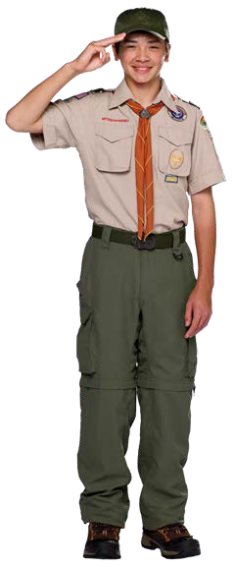
What Does Your Scout Need?The Scout Uniform
Scouting America is a uniformed organization. Just as one would wear a uniform when playing on a sports team, our policy is that Scouts are expected to be in uniform during
Troop meetings and activities. The uniform instills pride and ownership in the program and it also reminds Scouts of their obligations to uphold the scouting ideals and commitment to service. At registration, the Troop provides all Scouts with a Troop 212 t-shirt, a neckerchief, a neckerchief slide, “212” unit number patch, a name tag, green shoulder epaulets, and a handbook with cover. Other official Scouting uniform items and supplies are available at the Occoneechee Scout Shop, 3231 Atlantic Avenue, Raleigh, NC 27604: http://www.ocscouts.org/scout-shops/. Uniform Types
The Troop requires the Scout to have both a Field Uniform (Class A) and Activity Uniform (Class B).

CLASS “A” UNIFORM: Scouts are required to wear their Field Uniform to all formal Scouting activities like Courts of Honor, some Troop meetings, Scoutmaster conferences, Boards of Review, and to and from all outings. A Scout is expected to wear his/her uniform with the shirt buttoned and tucked in. The Field Uniform consists of the following items:
- Official Scouting short or long-sleeved khaki shirt with the appropriate patches, insignia, and epaulets properly attached
- Shorts and/or long pants (khaki or dark green)
- Matching socks (khaki or dark green)
- Official Neckerchief and slide (provided by the Troop)
- Official Merit Badge Sash (with earned merit badges – for formal occasions only)
- Matching web belt with Scout buckle or leather belt (unless pants are self-belted)
- Closed-toe shoes or hiking boots
While all of the above items may be purchased at the Occoneechee Scout Shop, please note that our Troop does not require Official Scouting pants, belts, or socks. However, these are highly preferred. Pants and socks of any durable material and color that complement the official uniform (e.g. green, khaki) are acceptable. Blue jeans and athletic shorts are not allowed.
Your Scout’s initial Field Uniform will require the following Insignia:

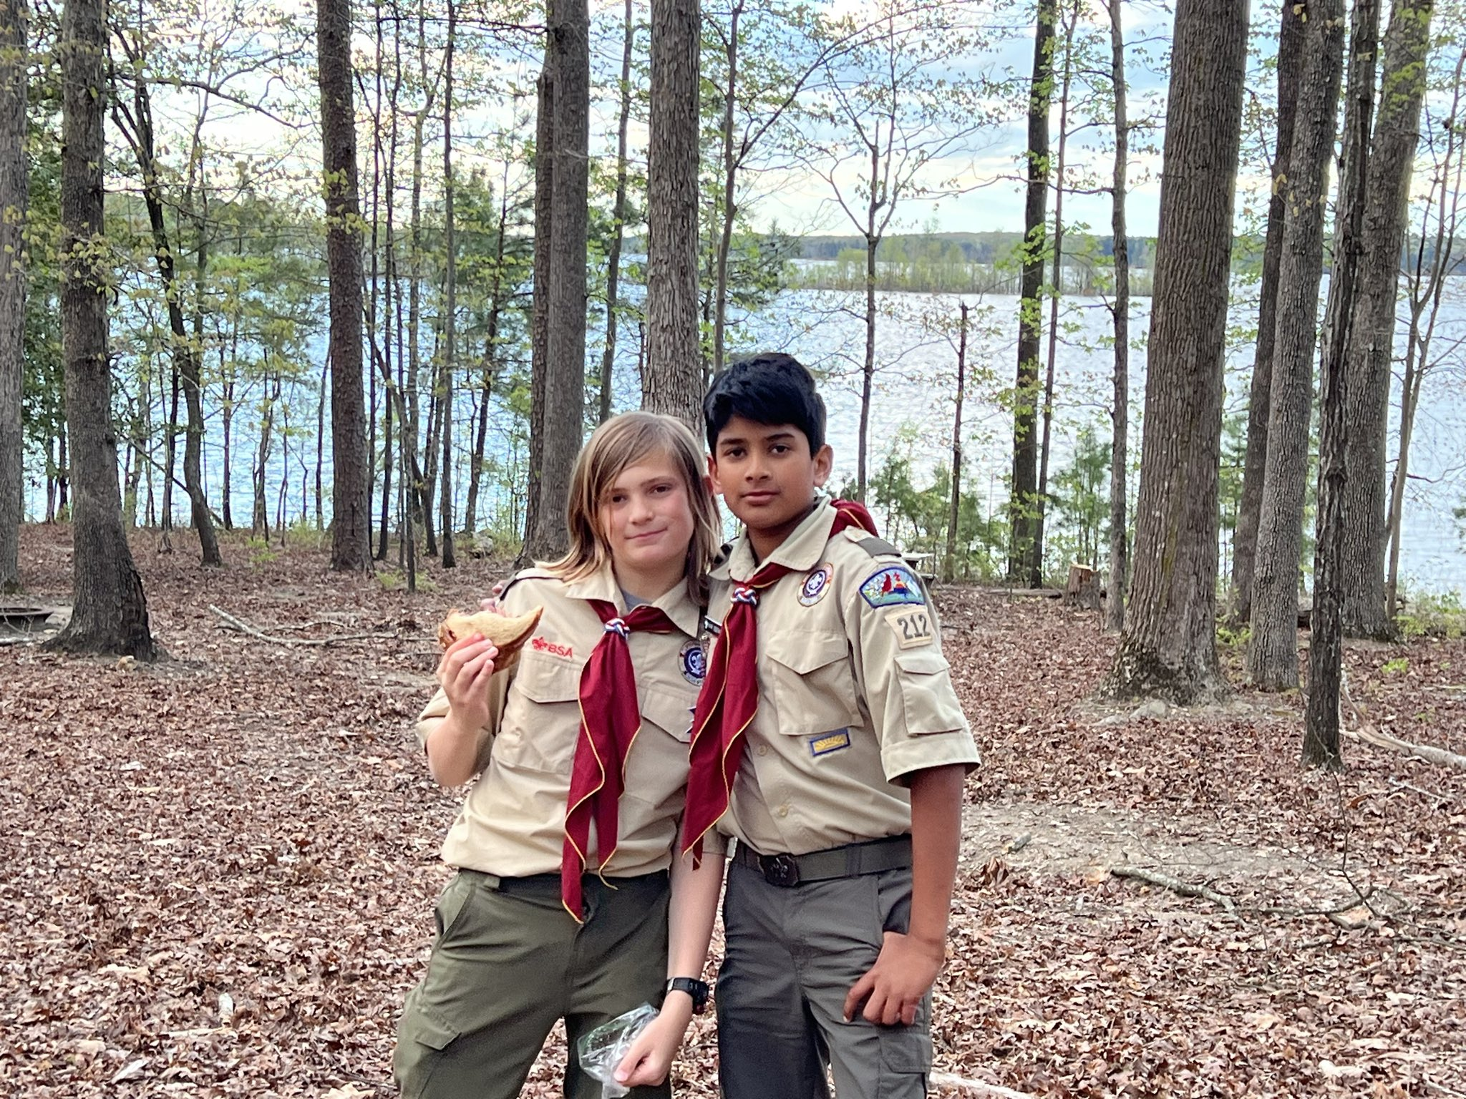
Occoneechee Council patch


Brown Numerals “212”
World Scouting Crest

World Crest Ring Emblem (optional)

As mentioned above, the troop issues each Scout a name tag. Please ensure your Scout wears the name tag above the uniform right-hand pocket. This helps Scouts and adult leaders learn new member names, and also ensures that advancements (aka, “sign-offs”) are assigned to the correct individuals.

All of these insignia are available at the Occoneechee Scout Shop. Correct placement of Field Uniform insignia is shown in the Scout Handbook and can also be found online at http://www.bsauniforms.org/. Patches must be placed on the uniform in the correct location and attached (sewn) in a neat manner. In addition, green epaulets should be attached to the shoulder button loops.
Merit badges, once earned, are worn in three columns on the dark green Merit Badge Sash. The sash is worn over the right shoulder of the Field Uniform and only on formal occasions such as Boards of Review, Courts of Honor, etc.
For members of the Order of the Arrow (OA), the OA sash is to be worn over the Scout’s Field Uniform at OA functions and other functions that render service to OA such as elections, camp promotions, and OA “callouts.” The OA sash is not to be worn with the Merit Badge Sash, at a Court of Honor or Scoutmaster Conference, nor is it to be worn folded over the Scout belt.

CLASS “B” UNIFORM: Scouts are required to wear their Activity Uniform (Class B) to Troop meetings, service projects, and during outings (Class A should be worn when official Troop transportation is being provided, both to and from the activity). The Activity Uniform consists of the following items:
- Troop 212 t-shirt (provided by Troop) or other official Scouting t-shirt
- Shorts and/or long pants (khaki or dark green)
- Matching socks (khaki or dark green)
- Closed-toe shoes or hiking boots
As with the Field Uniform, our Troop does not require Official Scouting pants, belts, or socks; these, however, are highly preferred. Pants and socks of any durable material and color that complement the official uniform (e.g. green, khaki) are acceptable. Please remember that blue jeans and athletic shorts are not allowed.

Camping Gear
Scouts will need personal equipment for outdoor activities. The list below provides most of the essential items. All camping gear should fit in a single bag, and be labeled with the Scout’s name.
- Water bottle
- Mess Kit (i.e. knife, fork, spoon, plate, bowl and cup)
- First aid kit
- Flashlight or headlamp
- Outdoor-rated sleeping bag
- Backpack or large duffle bag
- Clothing and closed- toed footwear appropriate to the season and activity
- Raincoat or poncho
- 2-Person Tent (seek advice from troop leadership)
- Compass
- Sun protection (hat, sunscreen, and/or long-sleeve shirt)
Additional information on camping supplies can be found in the Scout Handbook. Also, any of the Adult Leaders will be more than happy to provide suggestions and advice regarding the purchase of camping equipment. Please label all gear with your Scout’s name for easy identification.
NOTE: From time to time, other gear may be necessary depending on the type of outing. The Troop owns stoves and other camping gear to supplement the gear owned by our Scouts, and to help ensure that all our Scouts, particularly our newer and younger Scouts, are properly equipped. Older Parents also often have spare gear that they can lend to new Scouts upon request. Please don’t be afraid to ask the Scoutmaster or Committee Chair if you need anything.

Membership Application
Every Scout and adult leader must fill out an official Scouting America application to join the Troop. This can be completed at https://my.scouting.org.

In addition, each Scout and registered adult leader must have on file a current Scouting Medical Form. Parts A and B of the form, along with a copy of a current health insurance card (both front and back), are required to be on file in order to participate in any Troop weekend outing. Part C of the form, which requires a physical examination, is required for summer camp and all high-adventure activities. Each of these forms are valid for 1 year from the date of completion, though we will request new forms at the beginning of each year. The Medical Form can be found on the National Scouting website (http://www.scouting.org/). The medical information on the form will be kept in strict confidence, but it is very important. It lets the Troop leadership know about any medical situations that the Scout or adult may have (asthma, allergies, medical restrictions, etc.) and, in the event of an emergency, gives permission for a doctor to treat a Scout (or adult) if a parent cannot be reached. Please be truthful and thorough when completing the medical form.

How Much Will It Cost?
Scouting prides itself on delivering the most bang for your buck. While program fees are minimal, there are associated costs, like any other group activity.

Annual Dues
National and Council dues are paid online once a year directly to Scouting of America at https://my.scouting.org. In addition to National and Council dues, Troop 212 will also collect Troop dues once per year to support our local troop operation. Payment of dues entitles Scouts to hold positions of leadership within the Troop, attend meetings, camping functions, and any other Scout activities. If dues are not paid by the deadline, the Scout's membership is dropped from the Scouting America and Troop rolls. The money generated from dues is used for insurance, advancement material, annual re-chartering, and training classes for adult leaders. The Treasurer also provides regular updates on the Troop’s finances at Committee meetings.

Camping/Troop Activity Fees
The Troop tries to keep the cost of dues low. That means that sometimes we may need to collect fees for camping events or activities that have additional expenses associated with the specific event, such as grub costs, activities, and transportation. Fees will vary depending on the duration of the campout or activity (2 nights versus 1 night), the distance traveled, whether or not registration fees or park permits are required, and whether any special equipment is required for the activity. Check payments can be made, but leveraging the Troops Paypal account is preferred to pay for Troop activities. No cash payments are allowed. Failure to register and/or pay on time could result in a Scout’s exclusion from the event, and fees will still be required if a Scout withdraws from the Trip after Grub Planning.

Fundraising
As you might imagine, the annual dues that are collected cannot fully support the Troop for a whole year. The Troop requires additional funds to purchase equipment and help subsidize activities throughout the year. The Troop typically holds two fundraisers throughout the year.
- Luminaria: This is our only mandatory fundraising event and is held each year in December.
- Camp Cards: This is an optional event held each Spring. 50% of the cost of each card is put directly into the Scouts own personal account to cover any expenses (Summer Camp, Dues, etc.). This provides an excellent opportunity for Scouts to help both their Troop and cover their own expenses.
We are also thankful to have received donations from individuals as well as local corporations in the past, and we are always looking for new ideas.

Approximate Costs
- $200 – Annual Dues (amount based on yearly costs and fundraising)
- $150 – Scouting Uniform – one time (head-to-toe, hat, shirt, patches, pants, belt, socks)
- $15 – $20 – Camping Activities Fees (approximately monthly)
- $300 – $500 – Summer Camp
- $1200 - $2500 High Adventure activities (Optional)
- $300 – $500 – Camping equipment – optional, one time (pack, sleeping bag, boots, tent, etc.)
Scholarships are also available for higher cost events like High Adventure camps.
The Troop and Scouting America wants all youth to be able to participate in the Scouting program regardless of their personal financial situation; because of this, funds will be available for Scouts that are not able to afford the full costs. If you need financial assistance, please discuss these needs confidentially with either the Scoutmaster, Committee Chair, or Chartered Organization Representative.

Reimbursements
If you incur expenses in support of a Troop and have prior approval from the Troop Committee, you are eligible to be reimbursed for these expenses. This includes, but is not limited to, items like:
- Group meals / food for Troop events
- Equipment purchases or rentals
- Fees in support of Troop Outings (Camping Fees, Transportation, activities, etc.)
Towing the Troop trailer for Troop events may be reimbursed at $.35 per mile to cover the cost of transporting the trailer.
All reimbursement requests, along with the corresponding receipts, should be submitted to the Committee Chair and Treasurer for review and approval.

Communication
The Troop communicates with Scouts and parents in multiple ways. All activities are announced and discussed at weekly Troop meetings and this serves as the primary mode of communication with the Scouts. Please discuss upcoming activities with your Scout after weekly meetings.
In addition, the Troop maintains several additional means of communication. Please contact the Webmaster to set up accounts and obtain login information for the following:
- Email distribution lists for communication with both Scouts and parents
  - t212caryscouts@googlegroups.com
  - T212CaryASMs@googlegroups.com
  - t212carycommittee@googlegroups.com
  - To join, go to https://groups.google.com/u/1/g/t212caryscouts and ask to join the group, or contact the Scoutmaster or Committee Chair.
- We leverage Scoutbook to maintain all detailed logistical and registration information for all Troop activities in addition to all advancement and training records: https://scoutbook.scouting.org/mobile/dashboard/

Please encourage as much communication as possible through your Scout. Scouting is different from school, church, sports, and other youth organizations in that we are developing at least two things at once; the immediate practical goals (like getting a merit badge or going camping) and the much broader (and more important) goals of developing leadership, citizenship and physical, spiritual, and mental fitness. Communication by the Scouts themselves is an essential part of developing these skills.
Two-deep leadership must be maintained in all electronic communications with Scouts to ensure compliance with Scouting Youth Protection requirements. All electronic communication, whether sent from a Scout or to a Scout, must have at least one of the Scout’s parents/guardian or a second leader copied on the communication.
We encourage open, constructive communication between parents, leaders, and committee members. If you have any concerns, bring them to the Scoutmaster, Committee Chair, or Chartered Organization Representative and the issue will be addressed in a timely manner.
Please understand though that Wednesday nights between 7:30 pm to 8:50 pm is the time for the leaders to interact with the Scouts in the Troop. Unless a situation requires immediate attention, or you have scheduled a meeting with a leader, please speak with the leaders after 8:50 pm. All issues that do not directly involve the Scouts themselves should first be taken to the Committee Chair or Chartered Organization Representative.

Organizational Structure

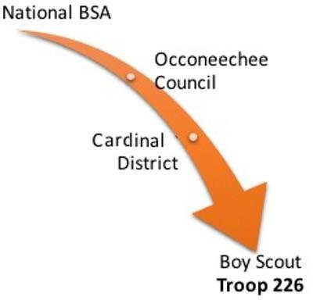
Troop 212
Nationally, Scouting America is broken down into large regions called Councils, and Councils are further divided into Districts. Districts are made up of Cub Scout units called “Packs”, Scout units called “Troops”, and Venturing units called “Crews”.
Troop 212 is a member of the Cardinal District, which in turn is a part of the Occoneechee Council. Our Chartering Organization, St. Michael the Archangel Catholic Church, sponsors our Troop. The Chartering Organization supports the Troop and is responsible for approving leadership, oversight of our finances, and providing us with a place to meet.

The following sections provide an overview of the organizational structure of the Troop. We first identify the primary leaders of the Troop known as the “Key 3”. We then provide details of the additional Direct Contact Leaders (Assistant Scoutmasters) and the Troop Committee structure, followed by the Youth Leadership structure.
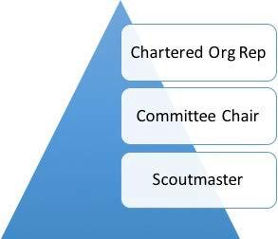

Leadership (Key 3)
Scouting utilizes the concept of a “Key 3” leadership structure at all levels in the organization. For the Troop, the Key 3 is comprised of the Troop’s Scoutmaster, Committee Chair, and Chartered Organization Representative.

Chartered Organization Representative
The Chartered Organization Representative (COR) is the direct contact between the Troop and the Chartered Organization. This individual is also the organization's contact with the Local Council and the District Committee. The COR is a voting member of the Council and may become a member of the District Committee. The COR oversees all Scouting Units (Pack, Troops, Crew) at St. Michael the Archangel Catholic Church and appoints the Troop Committee Chairs.

Committee Chair
The Troop Committee Chair is appointed by the chartered organization and registered as an adult leader of Scouting America. The Troop Committee Chair appoints and supervises the Troop committee and Troop leaders.

Scoutmaster
The Scoutmaster is appointed by the head of the chartered organization and is the adult responsible for working directly with the Scouts to help them create the program for the Troop. The Scoutmaster trains youth leaders to run the Troop by providing direction, coaching, and support.

Direct Contact Leaders

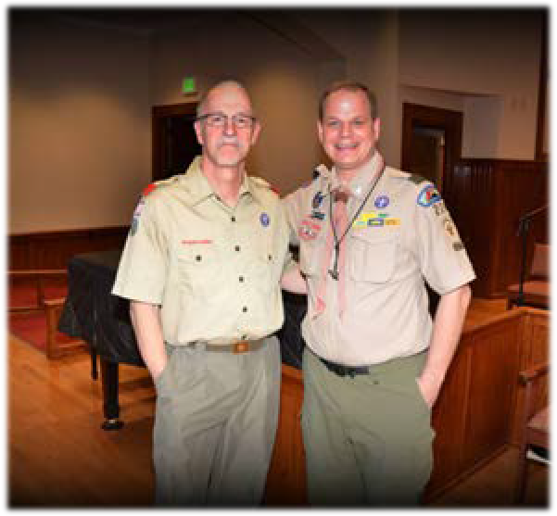
The Scoutmaster and Assistant Scoutmasters (ASMs) work directly with the Scouts to help them advance, learn new skills, and live by the Scout Oath and Law. The Scoutmaster and Assistant Scoutmasters accompany the Scouts on Troop outings. All direct contact leaders must be Youth Protection Trained.
As described previously, the Scoutmaster is ultimately responsible for a quality program that provides opportunities for advancement, leadership experience, and an exciting outdoor program. He/She also maintains the safety of the Scouts. The Assistant Scoutmasters are responsible for specific areas of the Troop Program based upon their interests and expertise and the needs of the Scouts, for example: working with program activities, Troop Guides, merit badge
counselors, Den Chiefs, and organizing camping or high adventure activities.

Assistant Scoutmaster Expectations
Every effort will be made to share the responsibilities for overseeing the planning and conduct of Troop activities amongst the Troop adult leadership. Therefore, below is a set of expectations for ASMs involved in such activities:
- Work with the Scoutmaster and/or Patrol Leaders Council (PLC) to identify activities during the year that you would like to help oversee.
- Ensure that activities are appropriately scheduled on the Troop calendar.
- Take the lead in making arrangements in advance, as needed, e.g., campsite reservations and payments.
- Attend the appropriate PLCs to discuss the event planning.
- Ensure that adequate adult leadership (e.g., two-deep) is in place and assure that proper adult training (e.g. First Aid/CPR, Trek Safety, Safe Swim, etc.) has taken place.
- Distribute activity information at the appropriate time to the Troop. Consult with the Troop Committee, if necessary, regarding event costs.
- Have Scouts discuss the event openly with the Troop at a weekly meeting.
- Communicate all final travel arrangements.
- Check with the Troop Committee/Scoutmaster regarding records of any special medical needs or issues with the Scouts. Obtain medical records and be responsible for them for the event. Return the records to the Troop upon completion of the event.
- Be responsible for taking the Troop first aid kit to the event.
- Oversee the event, ensuring that appropriate youth leadership is in place and working properly. Make every effort to allow the youth to run the event, to a reasonable extent.
- Ensure actual event attendance is consistent with Troop sign-up records.
- After the event, document and discuss any ‘performance issues’ with the Scouts, as appropriate. Include praise for any Scout who demonstrated good spirit, leadership, etc.
- In line with the point above, also share this information with the Scoutmaster and their Patrol ASM. This will be valuable information in future coaching sessions.

Assistant Scoutmaster Training

Troop 212 realizes that training is very important. A trained leader is knowledgeable and more confident in the role being performed. Trained leaders exhibit a knowledge and confidence that is picked up by the people around them. Trained leaders impact the quality of programs, leader tenure, youth tenure, safety, and a whole lot more. A trained leader is better prepared to make the Scouting program all it can be! We thus encourage all Assistant Scoutmasters to become Scouting America trained.
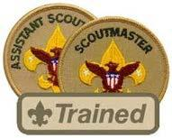
Adult leaders are considered trained and eligible to wear the official “Trained” emblem when they have completed Scoutmaster and Assistant Scoutmaster Position-Specific Training and Introduction to Outdoor Leader Skills (IOLS). Both are in-person trainings.
The Scoutmaster and Assistant Scoutmaster Position-Specific training is then followed-up by Introduction to Outdoor Leader Skills (IOLS). Here, one works through all of the Trail to First Class activities (minus the swim tests) with fellow leaders. This typically occurs either over a weekend camping trip activity or through daily activities at summer camp.
Adult leaders can continue their training through Wood Badge, a Scouting leadership program and related award for adult leaders (http://ocwoodbadge.org).
In addition, there are a number of on-line training modules at my.scouting.org that leaders should take. One can check the Council calendar at http://www.ocscouts.org/calendar-all/ for a schedule of upcoming opportunities.
- Weather Hazards
- Safe Swim Defense
- Safety Afloat
Finally, the Catholic Diocese of Raleigh requires that all adult volunteers on any Catholic Campus complete Safe Environment training through the diocese website at https://dioceseofraleigh.safeenvironment.org/.
Leaders should ensure all training, along with their Scouting ID number, is recorded in their personal account at my.scouting.org.

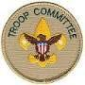
Troop Committee
The Troop Committee is made up of parents who meet approximately once a month to discuss issues and make decisions for the Troop. The Committee is led by the Committee Chair and must have a minimum of two members. This meeting is typically held during the Troop’s Patrol Leader’s Council and makes policy decisions, keeps records, and constantly monitors the program quality. Committee members are also welcome to join outings and help with special events. All parents are encouraged to attend these meetings, however, voting on Troop matters is restricted to Committee members.

Committee Leadership Positions
In order to serve on the Troop Committee, one must be a registered adult leader with Scouting America and complete the training requirements for their position. The Committee may appoint other members to serve on the Troop Committee as needed. Below are the present Committee positions for the Troop, and provide an opportunity to support the Troop with relatively little time and /or outdoor specific knowledge. Please contact the Committee Chair if you are able to support the Troop by serving on the Committee.
- Committee Chair

Treasurer

Membership / Recruiting Chair

Advancement Chair

Training Chair
- Board of Review Chair
- Summer Camp Coordinator

Quartermaster / Equipment Coordinator

Eagle Advisor(s)

Webmaster



Committee Training
For a Troop Committee member to be trained and thus able to wear the “trained” patch on their uniform, they must complete the following on-line training:
- Troop Committee Member Position Specific Training
- Youth Protection

Committee members should also read the Troop Committee Guidebook, especially the sections for the areas they oversee.

Troop Youth Leadership
The top youth position in the Troop is the Senior Patrol Leader, or SPL. Next is the Assistant Senior Patrol Leader, or ASPL. Senior Scouts also serve as Troop Guides, mentoring younger scouts. Then come Patrol Leaders, Assistant Patrol Leaders, and other Troop leadership positions like the Scribe, Quartermaster, Chaplain Aide, Historian and any other position listed in the Scout Handbook.
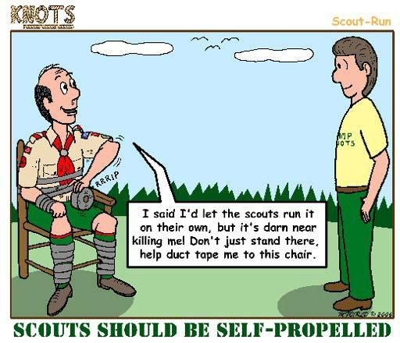
It is very important to remember that the real leadership in a Scout Troop comes from the Scouts themselves. Adults are involved to maintain safety, provide guidance when necessary, and make sure the aims of Scouting are being met. The Scouts should run the Troop. Lord Baden-Powell, the founder of Scouting, said "Never do a thing for a boy that he can do for himself." Allowing the Scouts to run the Troop provides opportunities for personal growth and leadership skill development.

Patrols
The Troop is organized into groups called Patrols. Patrols work together to develop pride in their group, learn new skills, go on outings, play games, etc. Patrols are mixed with youth of various ages so that each patrol has older Scouts available to guide and instruct younger Scouts.
Scouts who are newly bridged from Webelos will generally work with a Troop Guide, an older Scout who will help the new Scout get oriented and begin to learn basic Scouting skills. Each Patrol will also be assigned an adult mentor, generally one of the Assistant Scoutmasters. The Patrol structure helps to ease the transition and give the new Scout encouragement and guidance as he/she learns about Scouting.
Meetings are planned and run by the Scouts with the guidance of the Scoutmaster and Assistant Scoutmasters. Having the Scout leadership run the Troop meetings is an important part of helping the Scouts grow.

The Patrol Leaders Council (PLC)
The Senior Patrol Leader, Assistant Senior Patrol Leader(s), Patrol Leaders, and Troop Guides make up the Patrol Leaders Council, or PLC. The Scribe attends as an ex-officio member and records and publishes the minutes. The PLC is chaired by the SPL and typically meets once per month. Its purpose is to plan monthly meetings, trips, outings, and discuss issues that may be arising in the Troop. The PLC is the primary leadership organization within the Troop and is where the decisions that guide the Troop are made. The Scoutmaster, Assistant Scoutmasters and various Troop Committee members attend and provide appropriate support to the PLC.

Troop Elections
The SPL and PL positions are elected positions within the Troop. These are very important leadership positions that are vital to making the Troop function well. The SPL is elected by the entire Troop. Patrol Leaders are elected by their patrol. ASPLs are appointed by the SPL and the Assistant Patrol Leaders are appointed by the Patrol Leaders. Elections are typically held every six months. The Scoutmaster has the right to remove any leader at his/her discretion.

Junior Leader Positions
This section calls out the leadership positions in the Troop. Leadership is important to advance in rank, to have a good program, and to develop as a young adult. Even if the Scout does not currently hold a leadership position in the Troop, he/she should make sure to understand the responsibilities of those that do. Those being led should take responsibility to make sure that who they choose as leaders perform their duties. The following are elected positions for the Troop:
- Senior Patrol Leader
- Patrol Leader

Some of the Troop positions are selectively filled by the positions’ superiors. The following are appointed positions for the Troop:

- Assistant Senior Patrol Leader(s)
- Assistant Patrol Leader
- Troop Guide
- Junior Assistant Scoutmaster
- Troop Quartermaster
- Troop Scribe
- Troop Historian
- Troop Librarian
- Chaplain’s Aide
- Den Chief
- Bugler
- OA Troop Representative

Scout-Led Activities

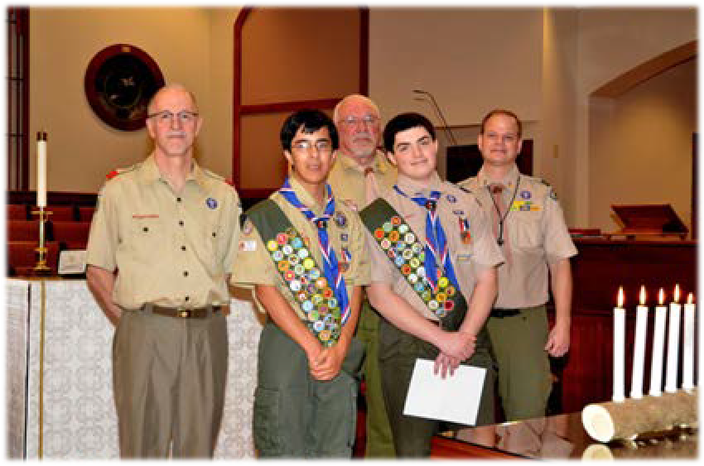
Weekly Meetings
Troop 212 meets every Wednesday evening during the school year (typically from August to June) from 7:30 pm to 8:50 pm in the Parish Center of St. Michaels the Archangel Catholic Church. Please note that if the Wake County Public Schools are canceled for inclement weather or there is a school-observed holiday, the Troop meeting will also be canceled.
Each Scout is expected to arrive at meetings on time, in uniform, and with their Scout Handbook. It is our hope that meetings will be both fun and productive. A typical meeting schedule is as follows:
- Gather for the opening ceremony and hear announcements of upcoming events
- Make plans by patrol for upcoming activities and outings
- Work on rank advancement, including merit badges, either in small groups or individually with older Scouts or a merit badge counselor
- Gather for the closing ceremony
Some of this is dependent on the Scout-led nature of the meeting as well as the Scouts' level of participation and behavior during a meeting.
The Troop Scribe records and posts Troop meeting minutes to our website, and the Troop Historian documents and periodically posts other Troop events and activities.


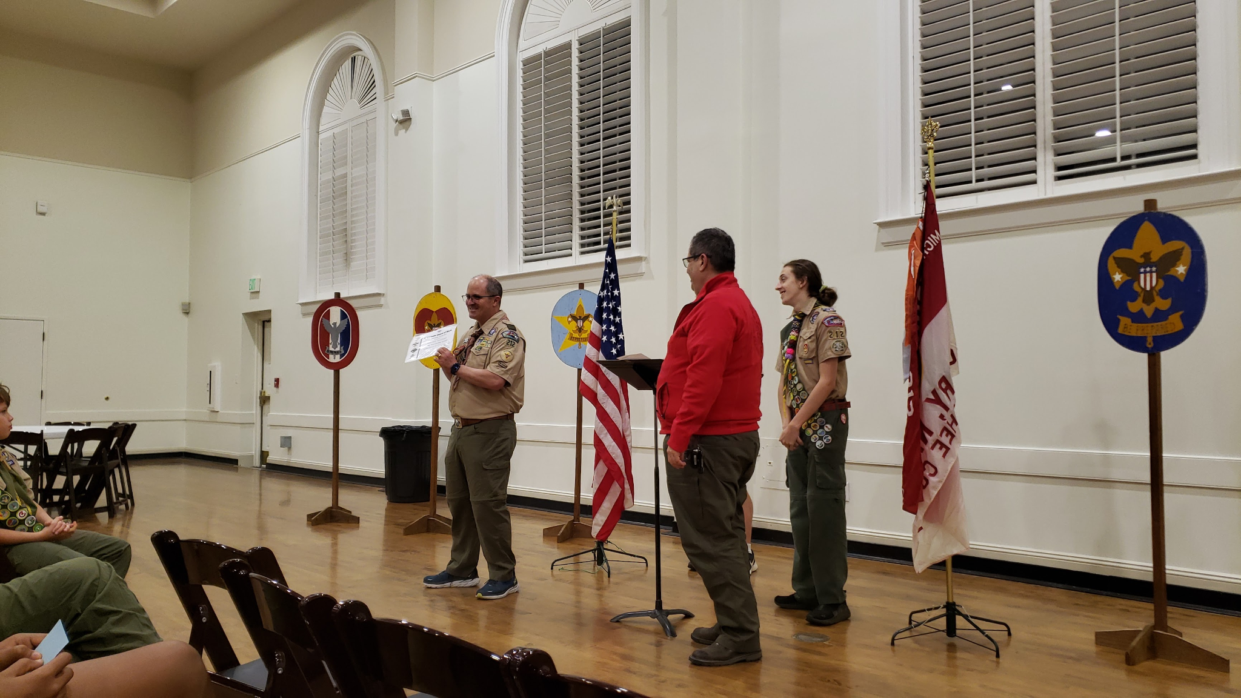
Courts of Honor
Each quarter, the Troop holds a “Court of Honor” to recognize our Scouts’ achievements in rank, merit badges, and other Scouting honors. Parents and guardians are strongly encouraged to attend in support of their youth, and extended families are also welcome to attend. These ceremonies also provide an opportunity for families to hear details of the past quarter’s activities, as well as learn more about upcoming Troop events. Scouts are expected to be in their full Field Uniform (Class A) for Courts of Honor.

Troop Outings
In addition to regular Troop meetings, the Troop conducts approximately one weekend activity per month. These are planned on a yearly basis based on input from the Scouts. Typically, one or two adult leaders will take responsibility for oversight of the logistics for each activity.
Only registered Troop leaders with Youth Protection training may accompany the Troop on outings, unless the outing is specifically designated as a family outing.
Most Troop Activities will take off from the Food Lion Parking Lot at 1777 W Williams St, Apex, NC 27523. We meet in the parking lot between the Bicycle Chain and Mr. Tire Auto Center. We will always meet with “a full stomach and empty bladder”.


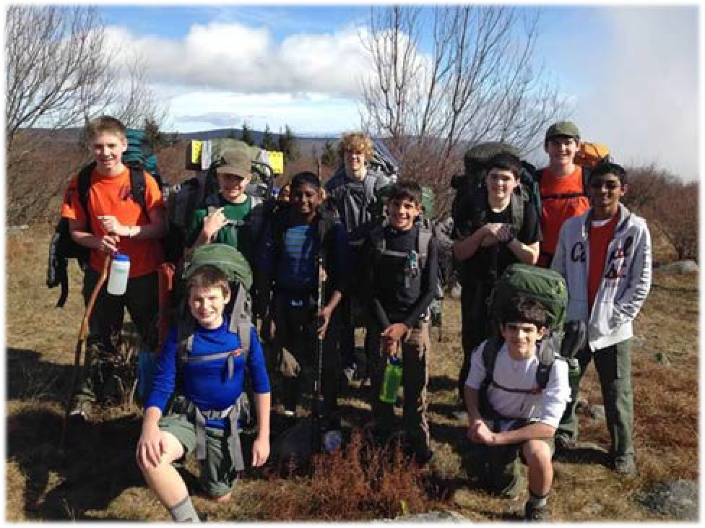
Camping
Camping is an exciting time for a Scout, but it is also a time of great responsibility. The Scouts will be expected to take most of the ownership for these trips by planning the trip, setting up their own camp, cooking their own food, washing their own dishes, and building their own fires. Scoutmasters and other adult leaders will always be available to provide guidance and assistance, but these trips are primarily the Scouts’ responsibility.
These trips are especially important in the learning process because they enable each Scout to enhance his/her learning experience by putting the skills that have been learned to use. We typically have two types of trips, backpacking and “car camping.” Some examples of weekend trips are:
- Backpacking along the Appalachian Trail at Mt. Rogers National Recreation Area
- Backpacking in Uwharrie National Forest Birkhead Wilderness region
- Backpacking and camping on the beach at Cape Lookout Seashore
- Car camping in William B. Umstead State Park
- Car camping at Jordan Lake State Park
- Car camping at Stone Mountain, NC
In order to participate in camping trips, the Scout is expected to attend appropriate planning meetings, which help to ensure a safe and successful outing. When attending weekend camping trips, it is the expectation that Scouts will stay for the entire weekend, unless prior approval is obtained from the Scoutmaster. In this case, parents must arrange a pick-up time with the trip leader and they may only transport their own Scout(s).
For trips where the Activity Leader has approved it, Hammock camping is allowed for Scouts that have achieved First Class Rank under the following conditions: No 360 degree flipping in the hammock, no double stacking hammocks, and you must be able to get into the hammock from ground level.
Note that the Troop will camp in all types of weather. Unnecessary risks however are never taken. Safety is the foremost consideration during all outings. Cancellation of any Troop function is at the discretion of the Unit’s Key-3.


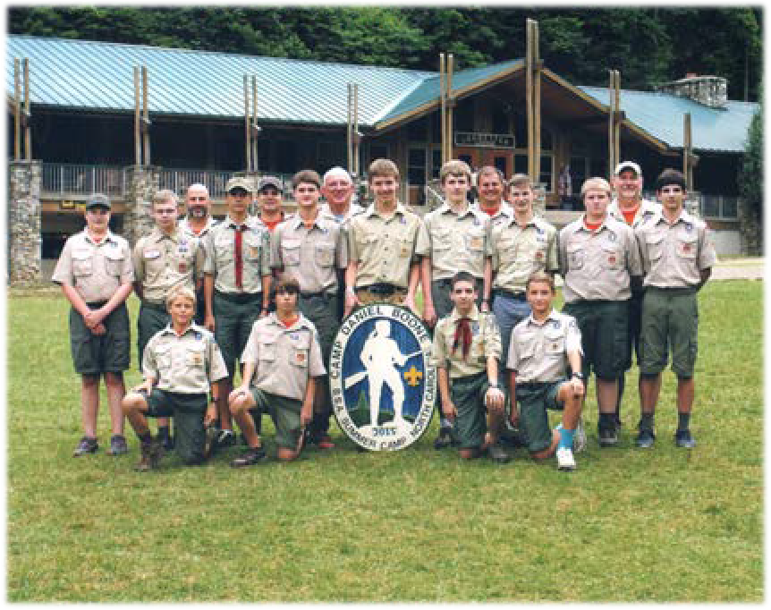
Summer Camp
Every summer, Troop 212 attends a weeklong summer camp. Summer camp offers each Scout advancement opportunities and outdoor challenges that he/she will remember for a lifetime. The summer camp program is for Scouts of all ages and ranks.
The first year camper program is designed for new Scouts to ensure they get off on the right foot. Scouts will participate in activities that will enable them to earn a significant number of requirements needed for the Scout,
Tenderfoot, Second Class, and First Class ranks, as well as the chance to earn the First Aid and other merit badges.
Older Scouts typically work on merit badges at camp, with the opportunity to earn or complete the majority of the requirements of up to about six badges. Areas typically include Aquatics, Nature, STEM, Shooting sports, Handicraft, and Leadership. In addition, Scouts have the opportunity to swim, fish, canoe, hike, participate in shooting sports such as rifle and archery, throw hatchets, go white-water rafting, do leatherwork, etc. It’s definitely a fun time for all!
Scouts looking for a more challenging summer experience may have the option of participating in high- adventure activities. These include week-long backpacking trips, whitewater rafting and zip-lining, rock climbing, or even going back in time and living history as if you were in the 1700’s.
Besides the activities listed above, the Scouts make many new friends and have a great time. Attending summer camp is one of the most important highlights of the Scouting year, and no Scout should miss out!

High Adventure
The Troop also plans to have high-adventure activities outside of summer camp on an every-other-year basis. These trips will likely be to one of the four High Adventure Bases: Florida Sea Base, Northern Tier, Philmont Scout Ranch, and The Summit Bechtel Reserve.

Special Rules
In the interest of the safety for all Scouts, as well as the enjoyment and successful learning experience of the Scouting program, common sense and good conduct is required at all times.
The following special safety rules are in place for all outdoor activities:
- NO tree, fence or rock wall climbing without specific leader permission.
- NO participating in aquatic activities without proper supervision.
- NO throwing of any objects except as part of an organized activity.
- NO use of cutting tools (ax, knife, etc.) or matches and fire starting materials without successful completion of the Totin' Chip and Firem'n Chit training, respectively.
- NO food in tents.
- NO flames or fuel canisters in tents.

In addition, the following items are not permitted on outings for either Scouts or adults:
- Sheath knives.
- Matches or pocket knives UNLESS the Scout has earned his/her Firem'n Chit and/or Totin' Chip.
- Alcoholic beverages or tobacco products.
- Firearms, ammunition or fireworks.
- Drugs OF ANY KIND. Required prescription drugs and non-prescription drugs must be given to the adult leader by parents prior to departure with Scout's name and written instructions for use. All medicines should be in the original container.
- Camouflage clothing.
- Excessive amounts of snack food or candy as determined by the outing leader.
- Hand-held electronics for entertainment.

Cell Phones
Scouts are permitted to carry a cell phone primarily to take pictures. Scouts will also be allowed to use these devices during downtime as defined by the Adult Leaders leading the activity, and those Adult Leaders maintain the right to confiscate devices if used inappropriately. Any scout that has a health or safety concern should notify the designated SPL for the trip and/or the adult trip leader as appropriate, BEFORE contacting a parent. This ensures that troop leadership can safely resolve any issues that might arise in the most efficient manner possible. While we understand that cell phones are a part of everyday life for many scouts and families, we ask that you consider leaving phones at home. In our experience, phones, and the charging thereof, become a distraction from the intended outdoor experience, and sometimes even lead to personal conflicts between Scouts. Tablets, laptops, and game-centric devices are not allowed at any time.

Community Service
Scouting was founded on the premise of “Do A Good Turn Daily”. Community service is very important in the character-building process and, as Scouts, we have made a commitment to give back to our communities. Rank advancement from “Scout” all the way to “Eagle” requires each Scout to participate in community service. The Troop identifies opportunities for Scouts to fulfill these requirements on a regular basis.

Advancement
Advancement is the responsibility of the Scout! Parents are encouraged to help, but the ultimate responsibility must lie with the Scout.
Through participation at Troop meetings, outdoor activities, and working on his/her own, Scouts will have the opportunity to work on skills and merit badges that will help them advance through the Scouting ranks. The first of these ranks is the Scout badge, which the Scout will earn by joining the Troop, learning basic scouting concepts, and having his/her first Scoutmaster Conference. After the Scout Badge, the Scout will continue through Tenderfoot, Second Class, First Class, Star, and Life. Finally, he/she may be able to earn the highest honor in Scouting, the Eagle rank.
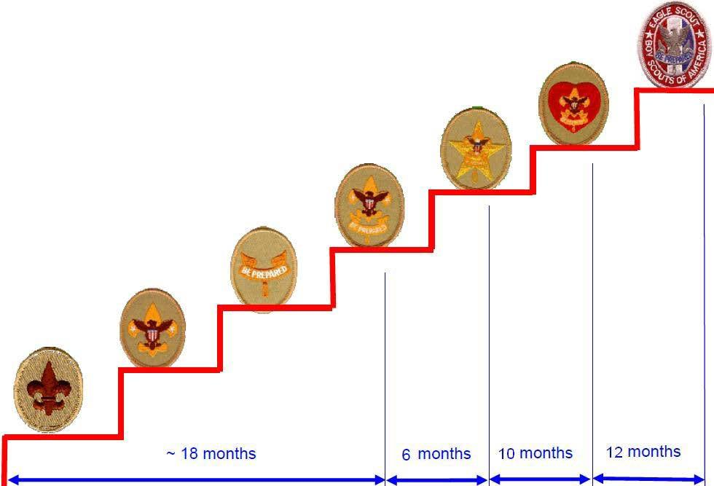

Eagle
Life
Star
First Class
Second Class
Tenderfoot
Scout
The Tenderfoot, Second Class, and First Class ranks require work mainly on the basic outdoor and first aid skills every Scout needs to know.
The Star, Life, and Eagle ranks require work on merit badges, leadership, and service to the community. The leadership requirement for these ranks can be fulfilled by actively and satisfactorily fulfilling a formal Troop leadership role. An approved project that provides a lasting improvement for the community must also be completed for advancement to the Eagle rank. All Eagle requirements must be completed before the Scout’s eighteenth birthday.
All ranks (except Scout) also have a requirement that Scouts must show Scout Spirit in their daily lives. How the Scout behaves at meetings and during outings is usually the greatest measure of Scout Spirit and will affect the decision of the Scoutmaster to sign off on this requirement and permit advancement. Scout Spirit also includes behavior outside of scouting.
Troop 212 also encourages all Scouts to participate in all activities, however a minimum of 50% of both Troop meetings and events and 50% of all outdoor activities should be viewed as a minimum expectation to be actively engaged in the Troop. Participation in Troop activities is a measure of Scout leadership fulfillment and Scout Spirit. Scouts are expected to participate in all aspects of the Troop program to the fullest extent possible.
After the requirements for a rank are completed, the Scout must schedule a Scoutmaster Conference followed by a Board of Review. Once the Scoutmaster Conference and Board of Review are successfully completed, the Scout earns his/her rank. A Scout may advance at any time once the requirements for the rank have been achieved and the Scoutmaster and Board of Review have approved the advancement. The advancement will take effect immediately after final approval of the Board of Review. However, formal recognition of the advancement will take place at the next regularly scheduled Court of Honor.

Requirement Sign-Offs
Sign-offs are a critical element of Rank advancement. Sign-Offs require approval by an Assistant Scoutmaster, and can not be approved by Committee Members. Senior Scouts (Star, Life, or Eagle rank scouts) may sign off requirements if done with the permission of and under the supervision of the Troop Scoutmaster.
Please note that sign-offs for Scout, Tenderfoot, Second Class, and First Class can be signed off in any order, but Star, Life, and Eagle ranks must be completed after achieving the previous rank.

Scoutmaster Conference

The Scoutmaster Conference is a time for the Scout and the Scoutmaster (or ASM for ranks up through First Class) to sit down and talk about how the Scout is progressing towards his/her next rank. The Scoutmaster will ask questions regarding how well the Scout has learned the items required for the rank he/she is completing. The Scout should come to the Scoutmaster Conference with his/her Scout
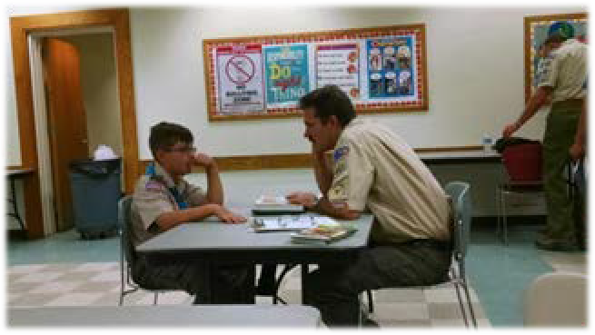
Handbook, wearing the full Field (Class A) uniform. They should be ready to talk openly and honestly about their scouting experiences. The Scoutmaster will be assessing the individual needs of the Scout, helping him/her to set goals for the next rank, and trying to gauge the success of the Troop program.

- Scouts seeking rank advancement beyond First Class, can request a Scoutmaster Conference at any time by notifying the Scoutmaster in advance. The Scout cannot just ask for a Scoutmaster Conference the night of a meeting without advanced notice.
- Unlike Cub Scouts, a parent is not authorized to sign off on their youth’s requirements. The handbook should also document activities (event and date) in fulfillment of community service hours and camping trips. If the requirements for advancement were completed at Summer Camp, then the Scout is responsible for having the requirements transcribed from any documents given at camp into his/her Scout Handbook.
- If the Scoutmaster (or ASM) does not sign-off during the Scoutmaster Conference, the Scout may be asked to review some of the requirements and schedule another Scoutmaster Conference when the Scout feels he/she is ready. Scouts need to know that if they need any help they must ask. There are many people – both other Scouts and adults – who are available to help the Scout succeed.
- After passing the Scoutmaster Conference, the Scout must schedule a Board of Review.

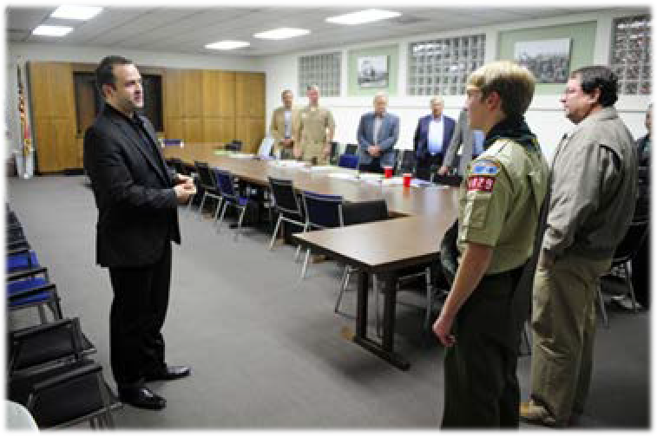
Board of Review
After completion of the Scoutmaster Conference, the Scout will appear before a Board of Review. A Board of Review is normally comprised of 3 adults who are not Assistant Scoutmasters nor the parent of the Scout (note that one member should be the Advancement Coordinator if available). Boards of Review are typically scheduled on a monthly basis.
Board of Review members will be selected to serve by the Advancement Coordinator and approved by the Troop Committee. At a minimum, one parent from each Board of Review Candidate will be required to participate in that Board of Review. Members serving on Boards of Review will receive training on how to conduct a Board of Review. Boards of Review shall be held for all Scouts who have completed a Scoutmaster Conference for rank advancement.
Prior to the Board of Review, it is the Scout’s responsibility to ensure that all sign-offs are completed in their physical Scoutbook, and that those signoffs are updated in the online Scoutbook system.
During the Board of Review, the Scout presents him/herself to the Board. The Scout must be in full Field Uniform (Class A), with appearance neat, a good attitude, and a respectful manner. He/she may be asked to repeat the Scout Oath, the Scout Law, the Outdoor Code, the Scout Motto, or The Scout Slogan. He/she will then be invited to sit down, and the Board will ask questions about his/her Scouting life. The questions can range very widely, so the Scout should be ready to communicate openly and honestly. The object of the Board of Review is to ensure that documentation is present verifying that all requirements for advancement have been met, to examine the attitude of the Scout in the Troop, and to ensure that the program offered by the Scoutmaster is fun, exciting, and meets the goals of Scouting. A Scout being considered for the Eagle rank, must undergo a special Eagle Board of Review, consisting of officials from throughout the District. The Scoutmaster and Eagle Advisor will work with the Eagle candidate to prepare him/her for the District Board of Review.
The Scoutmaster Conference and Board of Review can be stressful, particularly for the younger Scouts. It is important to remember that these experiences are part of the Scout's development as a young adult and help him/her to learn to communicate and handle interpersonal interactions in formal situations.

Merit Badges

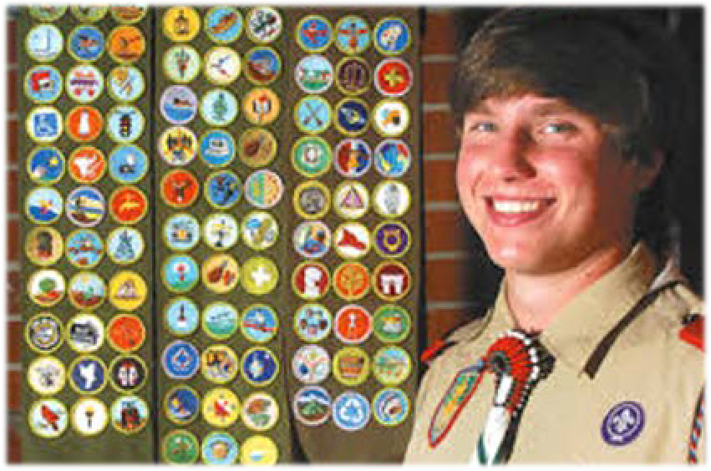
Merit badges are awards that concentrate on a particular field of expertise or a specific skill and can be earned by Scouts in cooperation with a Merit Badge Counselor. Each merit badge has an accompanying booklet that can be borrowed from the Troop library, purchased at the Scout Shop, or in some cases purchased on-line. There are over 100 merit badges available, and some are required before a Scout can earn the Star, Life, or Eagle ranks. The required merit badges can be earned in any order. Consult the Scout Handbook for information on which merit badges are optional and which are required.
Merit badge opportunities are also offered at summer camp and local merit badge colleges; announcement of these opportunities will be given at Troop meetings or by Troop mailings.
The following policies govern Troop merit badge work:
- The Scout should approach a Scoutmaster and ask to begin working on a particular merit badge
- The Scoutmaster verifies that that the Scout has met any prerequisites for the merit badge (e.g. pass swimming requirements before canoeing or lifesaving merit badges)
- The Scout will be assigned a Merit Badge Counselor
- The Scout is then responsible for contacting the Merit Badge Counselor, asking for help working on the badge, and setting up the first meeting time
- Merit badge work is performed outside of the Troop meetings unless scheduled as part of the Troop program
- When the merit badge is complete, the Merit Badge Counselor will sign off the requirements in Scoutbook. These records are very important.
- Meetings with a Merit Badge Counselor must be with a buddy, either another Scout or an adult. Scouts should never meet with a Merit Badge Counselor without someone else being present
- Maximum time limits to complete a merit badge are directly controlled by the Merit Badge Counselor; minimum time will be controlled by the merit badge requirements. Every merit badge will have limits to ensure the Scout is learning and displaying the skill necessary to complete the merit badge.
- The Merit Badge will be awarded at the next Court of Honor; merit badges are worn on the merit badge sash.
The Troop appreciates the involvement of parents in the Merit Badge process. If you have expertise or knowledge of a particular Merit Badge topic and would be willing to serve as a Merit Badge Counselor, please contact the Advancement Coordinator or Scoutmaster.
A Scout may not use a parent as their Merit Badge Counselor unless the Advancement Coordinator and Committee Chair grant approval; this will usually occur only when there are no available counselors within reasonable distance for the merit badge in question or the merit badge is taught to a group. Under no circumstances may a Scout use a parent as the Merit Badge Counselor for an Eagle required merit badge.

Expectations of Scouts for Participation
Most advancements in Scouting require the Scout to be active in the Troop for some period of time. In order to ensure that all Scouts are consistently and fairly treated in their Scouting journey, the following expectations are required to to be considered active within Troop 212.
- Attend a minimum of one weekly meeting per month.
- Attend a minimum of 2 Troop outings per Scouting season (i.e. Fall or Spring)
- For any attended event or outing, you must attend the full meeting.
- Older Scouts should support the SPL in providing instruction to younger Scouts.
- Abide by rules set forth in this document (i.e. uniform standards, cell phone usage, etc…).
- To request an exception to any of these rules, please speak with the Scoutmaster.

Expectations of a Scout Parent
The support and involvement of parents and family members in Troop 212 is what has made the Troop so

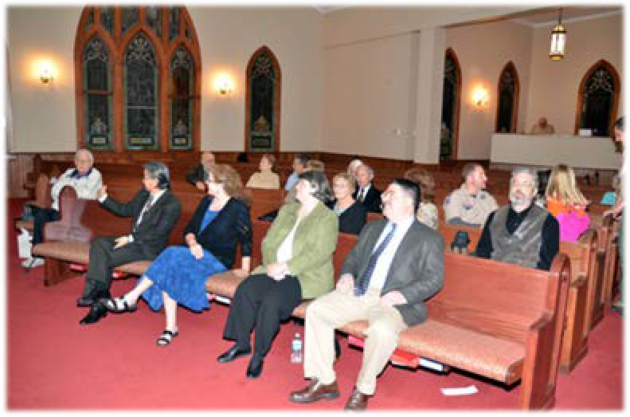
successful throughout the years. As a parent, you will have to decide how active you can be based on your family situation and its demands, but there are always positions available for which the Troop needs help.
Adult leadership is key to our Troop’s success. Parents are expected to support the Troop in some way. This could be anything from becoming a member of the Troop Committee, one of the Assistant Scoutmasters, and/or a Merit Badge Counselor to driving Scouts to / from events. We have many positions that require only a few hours of your time, both on a single day and on recurring schedules.
Experience has shown that parental involvement, either in a leadership or a support role, has a direct bearing on the Scout’s motivation and the accomplishments he/she achieves. Please keep this in mind when your help is requested.

It’s a Scout-Run Program
It is important for parents to remember that Scouting is a Scout-run program, not an adult-led program. The Scout-run Troop is one of the most basic and important principles of the Scouting program. If a parent participates in an activity, it is very important that s/he do their best to be adult Scout leaders, not parents. In order for the Scout program to succeed, the Scouts have to be free to make decisions, succeed, fail, and learn by running their own Troop. Failure is sometimes the best teacher, and success is a reward both for the Scouts and the adults who guide them. Parents should not be offended if the Scoutmaster or Assistant Scoutmaster asks them not to make suggestions or to help in certain situations, and should not worry when the Scout leader appears to be letting the Scouts make a bad decision. Adult leaders are there to guide and maintain safety, and we will never allow a Scout to make a mistake that would compromise their safety. Being a Scout leader is not easy in any capacity and becomes even harder when your own youth is involved. Rest assured that the adult Troop leaders want parents to participate in all aspects of the Troop, and they will do anything they can to make the experience fun and rewarding.

Parental Duties
The parent of a Scout should:
- Enjoy the Scouting experience alongside your youth
- Provide the necessary uniform, equipment and transportation for your Scout so that he/she is properly clothed and equipped to participate in Troop activities
- Provide important information to the Scoutmaster or one of the Assistant Scoutmasters regarding any problems or concerns unique to you or your Scout, such as medical conditions, medications, learning disabilities, etc.
- Encourage your Scout to honor the Scout Oath, laws, and slogan both during Scouting activities and especially at home; demonstrate your commitment to his/her success in Scouting by modeling these principles daily
- While every Scout must juggle Scouting with other life activities (e.g. family, school, and sports time), keep in mind that the success and enjoyment of the Boy Scout increases as the Scout's participation increases and encourage your Scout to set and abide by priorities which will help further the Scouting experience.
- Allow your Scout to "learn by doing". He/she will make mistakes when trying to accomplish tasks on his/her own, but this builds character! Remember, there are many older Scouts and adult leaders present to ensure that new Scouts don't do anything that jeopardizes their safety or other basic requirements.

- Encourage your Scout to attend summer camp! Experience proves that new Scouts are much more likely to stay in Scouting, enjoy Scouting more, and advance more quickly by attending summer camp.
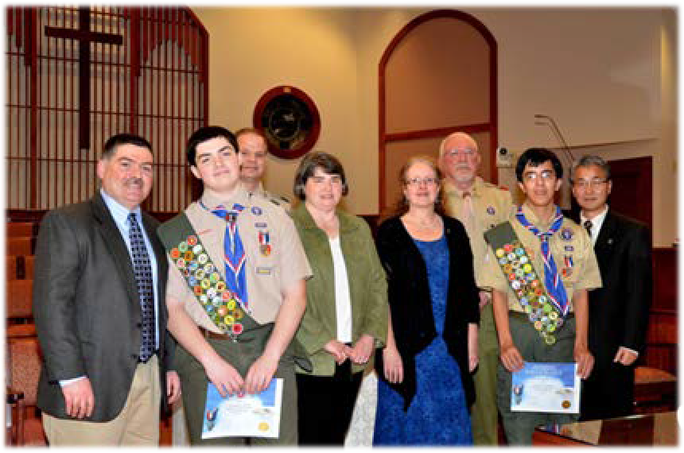
- Help your Scout to find the time to review, study and practice his/her advancement requirements, and if possible, test your Scout on those requirements so that he/she is more comfortable when reviewed by the Troop leadership. Remember that - in accordance with Scout policy - parents are not authorized to sign- off on advancement requirements for their youth.
- Attend and/or support Courts of Honor,
campouts, fundraisers, and other Troop activities. We strongly encourage your participation for both the Troop's and your youth's benefit.
Remember, suggestions or questions from parents are always welcomed. Present them to any committee member or send a note with your Scout to any meeting.

Code of Conduct
For ease of reference, the components to the formal Code of Conduct that all Scouts are asked to read and acknowledge annually are as follows:

Scout Oath
“On my honor, I will do my best to do my duty to God and my country and to obey the Scout Law; to help other people at all times; to keep myself physically strong, mentally awake, and morally straight.”

Scout Law
“A Scout is trustworthy, loyal, helpful, friendly, courteous, kind, obedient, cheerful, thrifty, brave, clean, and reverent.”

Scout Motto
“Be Prepared.”

Scout Slogan
“Do a good turn daily.”

Outdoor Code
“As an American, I will do my best to be clean in my outdoor manner, to be careful with fire, to be considerate of the outdoors, and to be conservation-minded.”

During all events and activities, Scouts are expected to live up to the rules established by Scouting America, the Troop, and the leaders. In the event that a Scout or adult does not follow these rules or threatens the health and safety of any of the Troop’s members, the leader in charge may take immediate remedial action, including - but not limited to - immediate suspension from the activity.
In general, failure to honor the Scout Oath, Law, Motto, Slogan and Outdoor Code will initially result in a Scoutmaster Conference, parent notification and assignment of re-training activities as deemed prudent by the Scoutmaster. However, as youth advance in rank, the expectations for leadership are higher. Upon ASM referral for disciplinary action, the Scoutmaster will apply a graduated, “three strikes” program as follows:
Strike 1: SM Conference with Scout to develop improvement plan, parental notification, and re- training/education activities.
Strike 2: SM Conference with Scout and parents, removal from leadership positions(s), and a 30-day suspension from Scouting activities.
Strike 3: SM and Committee Conference with Scout and Parents, indefinite suspension for minimum of 60 days with SM and Committee approval required for re-entry
This is just a general guideline for disciplinary action for Troop 212. Scouts and parents should remember that the Scoutmaster may exercise his/her discretion regarding application of the consequences above depending on severity of offense; up to and including immediate and permanent dismissal from a specific activity or the Troop.

Damage to Troop Equipment & Property
The Troop has a lot of equipment for Scouts to use. Scouts are expected to take good care of the equipment. If a Scout deliberately or negligently damages equipment, they will be responsible for the repair, replacement, or reimbursement to the Troop for the cost.

